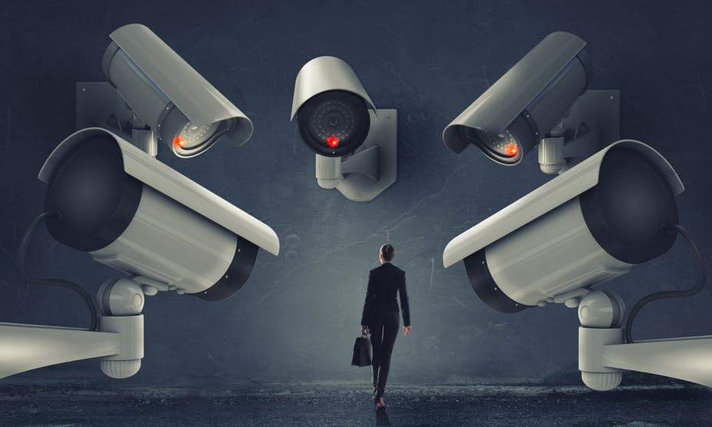

Amrath

alpha cctv consultants

BUSINESS PROPOSAL

2023

Prepared by:

Anas Amrath

Business development manager

Phone-0115472636

Email-alpha@gmail.com

Contents

1. Executive Summary – Introduction / Objectives…………………………….... 1
2. Company Overview - Alpha Security Consultants…………………………….2
3. Product Description - CCTV Solutions ………………………………………….3,4
4. Market Analysis - Industry Overview…………………………………………….5,6
5. Unique Selling Proposition (USP) - Alpha Security Consultants………………7
6. Marketing Strategy - Pricing Strategy…………………………………………….8

07. Sales Strategy - Sales Forecast………………………………………………….9

BUSINESS PROPOSAL

alpha cctv consultants

**Inception of Alpha Security Consultants**

Born from a vision to redefine security solutions, Alpha Security Consultants, since [Ye], has stood as a symbol of innovation and excellence. Our journey began with a commitment to personalized service and adaptability, growing into a trusted name that provides not just security but peace of mind.

Executive Summary

Introduction:

Alpha Security Consultants aims to provide cutting-edge CCTV solutions, ensuring the safety and security of businesses and homes.

**Innovation Hub:** A pioneer in CCTV technology, always at the forefront of innovation.

**Tailored Excellence:** Specializing in customized security solutions, ensuring a perfect fit for every client

.

**Client-Centric Values:** Built on transparency, reliability, and a deep understanding of client needs.

**Industry Recognition:** Acclaimed for excellence and technological prowess in the security industry.

**Community Involvement:** Actively engaged in initiatives promoting security awareness and education.

Alpha, security isn't just a service; it's a commitment to shaping the future At of safety.

Top of Form

Objectives:

Introduce a comprehensive range of CCTV products.

Capture a significant market share within the first year.

Company Overview

stablished in [Year], Alpha Security Consultants is a leading provider of cutting-edge security solutions. Our commitment to innovation and client satisfaction sets us apart in the competitive landscape of security technology.



**Key Points:**

* **Founding Principles:** Founded on principles of innovation, transparency, and client-centric values.
* **Specialization:** Experts in delivering tailored CCTV solutions to meet the unique needs of our clients.
* **Recognition:** Industry-acclaimed for our contributions to security technology and excellence.
* **Client Relationships:** Built on trust, reliability, and a commitment to understanding and meeting client needs.
* **Community Engagement:** Beyond business, we actively contribute to community initiatives promoting security awareness and education.

Alpha, security isn't just a service; it's a commitment to shaping the future at of safety.

ProductDescription

CCTV Solutions:

At Alpha Security Consultants, our CCTV solutions are designed to provide cutting-edge security measures for businesses and residences. Our product line comprises high-definition cameras and advanced surveillance systems to meet the diverse needs of our clients.

High-definition Cameras:

Our high-definition cameras deliver crystal-clear imagery, capturing every detail with precision. Equipped with the latest technology, these cameras ensure optimal performance even in challenging lighting conditions.

Advanced Surveillance Systems:

Our advanced surveillance systems integrate seamlessly with various camera types, providing a comprehensive security network. These systems are designed to be user-friendly while offering sophisticated features for effective monitoring and threat detection.

Types of Cameras

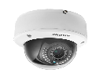

[This Photo](https://freepngimg.com/png/51149-cctv-dome-camera-free-download-png-hq) by Unknown Author is licensed under [CC BY-NC](https://creativecommons.org/licenses/by-nc/3.0/)

Dome Cameras:

360-Degree Coverage: Dome cameras offer a wide field of view, making them ideal for monitoring large spaces.

Discreet Design: Their compact and inconspicuous design is suitable for environments where aesthetics matter.

Vandal Resistance: Built to withstand tampering and vandalism, ensuring long-term durability.

Bullet Cameras:

Long-Range Monitoring: Bullet cameras are designed for extended-distance surveillance, making them suitable for outdoor applications.

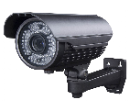

[This Photo](https://freepngimg.com/png/49663-cctv-camera-free-download-png-hq) by Unknown Author is licensed under [CC BY-NC](https://creativecommons.org/licenses/by-nc/3.0/)

Weather Resistance: With weatherproof casing, these cameras perform reliably in various environmental conditions.

Versatility: Easy to install and adjust, providing flexibility in positioning.

Pan-Tilt-Zoom (PTZ) Cameras:

Remote Control: PTZ cameras allow for remote control of pan, tilt, and zoom functions, providing flexible coverage.

Optical Zoom: High-quality optical zoom capabilities for detailed monitoring over long distances.

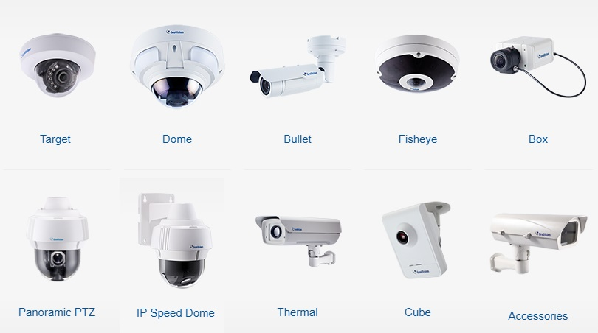Automated Tracking: Some models feature automated tracking of moving objects for enhanced security.

Surveillance Systems:

**24/7 Monitoring at Alpha Security Consultants:**

In the realm of security, Alpha never sleeps. Our systems maintain constant vigilance, offering real-time alerts for swift response to any suspicious activity. With secure cloud storage, scalability, and redundancy measures, we ensure your security infrastructure is not just robust but innovative and reliable. At Alpha, we prioritize your peace of mind and deliver CCTV solutions that stand the test of trust and efficiency.

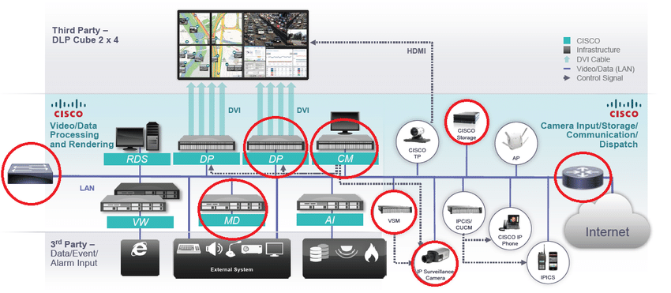Top of Form

Market Analysis

this trend by offering innovative CCTV solutions tailored to meet the demands of a dynamic market.

Target Market:

Small to Large Businesses:

Our primary focus is on providing comprehensive security solutions for businesses of varying sizes. Small businesses benefit from cost-effective yet powerful surveillance, while larger enterprises appreciate the scalability and customization of our offerings.

Residential Properties:

Recognizing the importance of home security, Alpha Security Consultants extends its services to residential properties. Our CCTV solutions provide homeowners with peace of mind, offering advanced surveillance tailored to the unique needs of private residences.

Competitor Analysis

Alpha Security Consultants operates in a competitive market, and understanding our key competitors is essential for strategic positioning and continuous improvement.

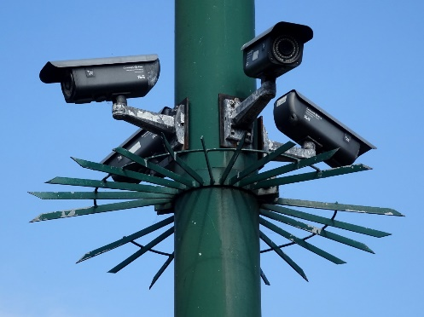

Key Competitors -

Security Solutions Inc. (SSI):

Strengths:

Established brand with a solid reputation.

Diverse product range, including access control and alarm systems.

Weaknesses:

Limited focus on high-definition CCTV solutions.

Higher pricing compared to market averages.

TechGuard Security Systems:

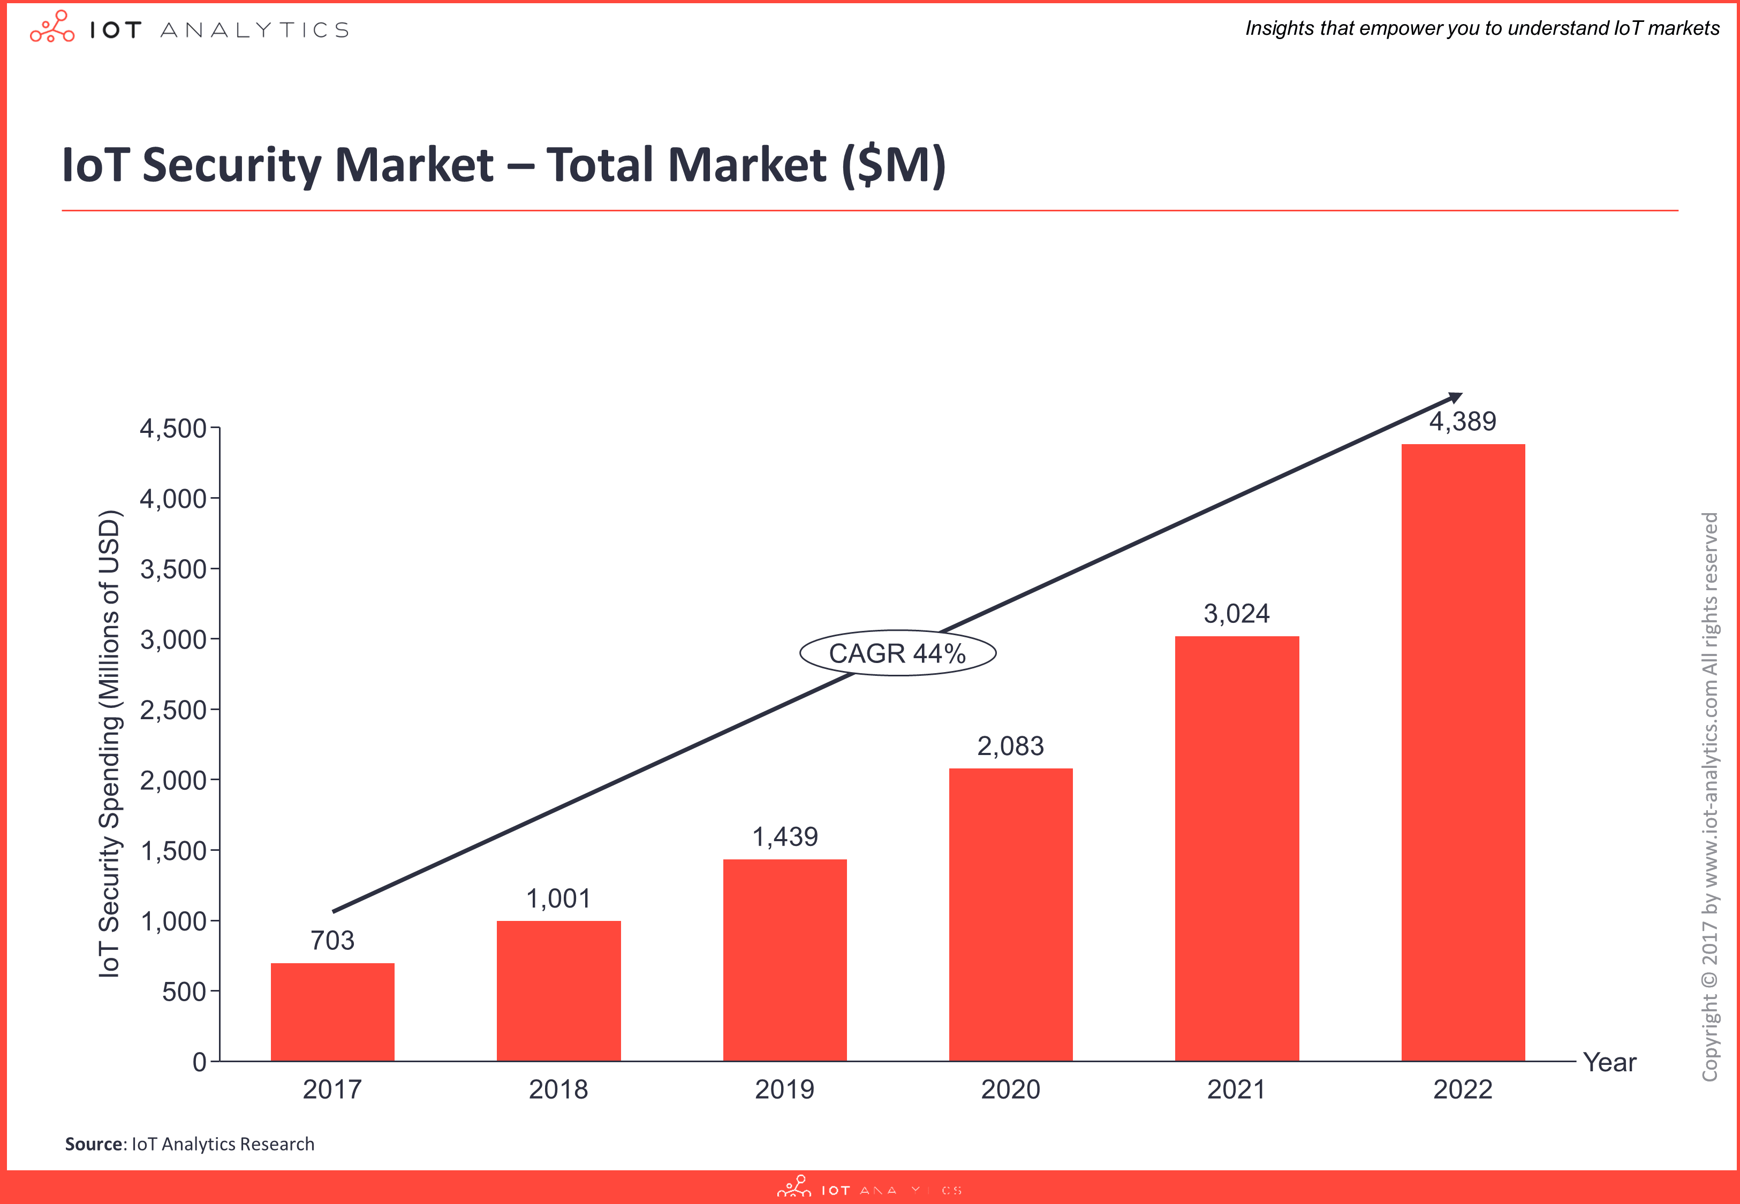Strengths:

Cutting-edge technology and innovation.

Robust after-sales support and customer service.

Weaknesses:

Limited market presence in the residential sector.

Relatively higher complexity in product installation.

Secure Home Solutions:

Strengths:

Specialized in residential security solutions.

Competitive pricing strategies.

Weaknesses:

Limited product diversity compared to industry leaders.

Less emphasis on cloud-based storage solutions.

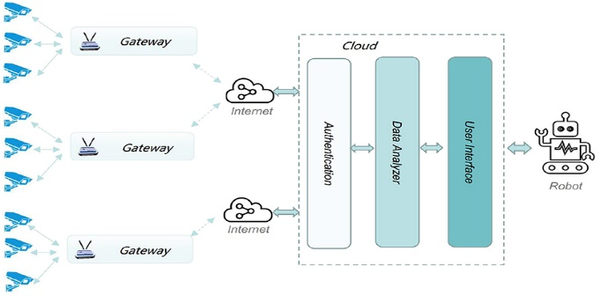

[This Photo](https://www.frontiersin.org/articles/10.3389/fnbot.2021.648101/full) by Unknown Author is licensed under [CC BY](https://creativecommons.org/licenses/by/3.0/)

Analysis

Opportunities:

Growing demand for cloud-based security solutions.

Increasing awareness of the importance of surveillance in residential areas.

Threats:

Rapid technological advancements led to shortened product lifecycles.

Intense competition from new entrants and established players.

Unique Selling Proposition (USP)

Alpha Security Consultants' Differentiators:

At Alpha Security Consultants, our commitment to delivering exceptional CCTV solutions sets us apart in the market. Our Unique Selling Proposition (USP) is centered around the following key differentiators:

Cutting-edge Technology:

We stay at the forefront of technological advancements, ensuring our clients benefit from state-of-the-art CCTV solutions with the latest features and capabilities.

Customization for Every Need:

Unlike one-size-fits-all approaches, we understand that each client has unique security requirements. Our CCTV systems are highly customizable, offering tailored solutions for businesses and residential properties.

Reliability and Durability:

Our products are engineered for longevity and consistent performance. We prioritize reliability, providing surveillance systems that operate seamlessly in various environmental conditions.

User-friendly Interface:

We believe that advanced technology should be accessible to everyone. Our CCTV systems boast a user-friendly interface, making them easy to install, operate, and maintain.

Comprehensive Support and Training:

Alpha Security Consultants goes beyond product sales; we provide comprehensive support and training to ensure our clients maximize the benefits of their security systems. From installation guidance to ongoing technical assistance, we are dedicated to our clients' success.

Marketing Strategy

Pricing Strategy:

Our pricing strategy is designed to be competitive while reflecting the value of our cutting-edge CCTV solutions. We offer flexible packages to accommodate the budgetary constraints of small businesses and the comprehensive needs of larger enterprises.

Distribution Channels:

Alpha Security Consultants employs a multi-channel distribution approach, ensuring our products are accessible to a wide range of customers. Our distribution channels include direct sales, partnerships with security integrators, and an online platform for residential customers.

Promotion and Advertising:

Digital Marketing:

Leveraging online platforms and social media to reach a broader audience.

Partnership Collaborations:

Establishing strategic partnerships with businesses, security firms, and influencers to expand our market reach.

Promotional Events:

Hosting events to showcase our products and engage with potential clients.



Sales Strategy

Sales Forecast:

Our sales forecast is based on a thorough analysis of market demand, pricing structures, and historical sales data. We anticipate a steady increase in sales, driven by growing awareness, effective marketing efforts, and the reliability of our CCTV solutions.



[This Photo](https://pressbooks.nscc.ca/nsccprinciplesofmarketing/chapter/reading-implementing-positioning-strategy/) by Unknown Author is licensed under [CC BY](https://creativecommons.org/licenses/by/3.0/)

Sales Tactics

In-depth Consultations:

Conducting consultations to understand the unique security needs of each client.

Product Demonstrations:

Offering live demonstrations to showcase the features and capabilities of our CCTV systems.

After-Sales Support Packages:

Providing tailored after-sales support packages to enhance customer satisfaction and loyalty.